

## Fundraising Toolkit

We are so thrilled to have you joining us for The Extra Mile® as we honor and celebrate individuals with Down syndrome! Thank you for helping us celebrate and support individuals with Down syndrome and their families and promote understanding and acceptance of those with Down syndrome

To help you and your team be successful in your fundraising efforts, we’ve put together some fundraising tips and some sample messages you can copy/paste to share with your networks.

💡**Tip:** Make a copy of this Google Doc so you can easily edit the personal messages to copy and paste! Click **File > Make a Copy** to save to your Google Account or **Download** to save to your computer.

**Jump to the resource you need 👇**

* Sample Messages (Email and Text)
* Sample Social Media Posts
* Tips for Using Your Pledge It Fundraising Page
* Fundraising Advice

## Sample Messages (Email and Text)

💡**Tip:** Personalized messages to your friends and family are much more successful than sharing on social media alone. Consider customizing your message with a personal story and sharing your connection to this cause. Including a photo of you with your loved one with Down syndrome is another way to create a personal connection! 📸

### Email

Dear [name],

I hope you’re doing well! I'm reaching out to share that I’m participating in The Extra Mile®, which provides incredible support for individuals with Down syndrome and their families in our community.

This cause is so close to my heart. [Share your personal connection to the campaign.] This organization makes a significant impact on the lives of those with Down syndrome, promoting inclusivity and acceptance in our community.

Would you consider making a donation to my page? You can donate here: [insert fundraising page URL]

Every donation counts, and I genuinely appreciate any contribution you can make. Your support will help provide essential services, education, and resources that empower individuals with Down syndrome, their families, caregivers, and more. ALL MONEY raised for DSAMT including from The Extra Mile® remains in Middle Tennessee. DSAMT is not under any requirements to send a portion of their funding to any National organizations.

Thank you for taking the time to read my email. If you have any questions or would like to learn more about The Extra Mile®, please don't hesitate to reach out to me.

All my best,

[your name]

### Text Messages

💡**Tip:** If someone didn’t respond to your email message, don’t fret - inboxes can be overflowing! Consider following up with a text message after a few days.

Hey friend! Not sure if you saw my email, but our family has signed up for The Extra Mile® and I’m fundraising in honor of [your loved one’s name]. The funds we raise provide important support for individuals with Down syndrome and their families in our community. I’d love your support! Would you be able to make a donation? No amount is too small! Here’s my fundraising page: [insert your fundraising page URL]

Hi [name]! I’m participating in The Extra Mile® to help raise funds for individuals with Down syndrome and their families. This cause is deeply important to me because of [your loved one’s name] and I’d love your help reaching my fundraising goal - any amount you can spare makes a difference! 💙💛 Here’s my page: [insert your fundraising page URL]

Hey [name]! Our family and friends are coming together in honor of [your loved one’s name] and joining The Extra Mile®, a fundraiser and celebration to raise funds for individuals with Down syndrome and their families. We’d love for you to join our tea!. You can also support by helping us reach our fundraising goal. Even a small donation helps. Here's our page: [insert your fundraising page URL]. Thanks so much! 💛💙

Hey [name], we’re just a few weeks away from The Extra Mile®! Would you be able to help my team out with a donation? Our family is so excited for this campaign but we’re still short of our goal. If we got just 5 people to donate [$amount] we’d be able to make it! I’d love your support if possible! Here’s my fundraising page, thank you for considering! 🙏 [insert your fundraising page URL]

## 

## Sample Social Media Posts

💡**Tip:** It’s easy to post a hyperlink on Facebook, but less so on Instagram. We recommend adding your fundraising page URL to your Instagram bio or adding a link to your Stories so your friends and family can easily reach your page!

You can help me make a difference for individuals with Down syndrome and their families! 💙💛 Our family is participating in The Extra Mile® and a donation to our team would support the incredible work being done for individuals with Down syndrome and their families. Thank you all for your support! 🙏[insert your fundraising page URL]

Friends, this is our family’s [first/second/third/etc] year participating in The Extra Mile®! This event grows more impressive each and every year and I’m honored to be a part of something that raises such important funds for individuals with Down syndrome and their families. Please consider supporting our family with a donation to help us reach our goal! [insert your fundraising page URL]

[Team name] needs your help! We are trying to make it to the top of the fundraising leaderboard for The Extra Mile® and any donation helps, no matter how small. Please consider making a donation to support our team. You can even sign up to join us on the big day! 💙💛 [insert your fundraising page URL]

We’re just a few weeks away from The Extra Mile® and our team needs your help! Can you make a donation in honor of [your loved one’s name]? 100% of the funds that we raise go to supporting individuals with Down syndrome and their families! ALL MONEY raised for The Extra Mile® remains in Middle TN. Thank you for considering! 🙏Donate here: [insert your fundraising page URL]

The BIG DAY is less than a week away! 📣 Our family is so excited for The Extra Mile®! We’ve been hard at work fundraising but we need all the support we can get to keep our team’s place on the Leaderboard! Please donate to help us support individuals with Down syndrome and their families in our community. 💛💙 Donate here: [insert your fundraising page URL]

## Tips for Using Your Pledge It Fundraising Page

### Customize your page

If you’re joining The Extra Mile®, it’s likely you know someone with Down syndrome that’s important in your life. Share your connection to the cause by customizing your fundraising page with a unique photo and message.

**📝 HOW TO:** Start by visiting your fundraising page while logged in. If you’re on a desktop, click the “Edit” button directly below the cover photo on your fundraising page. If you’re on a mobile device, click the pencil icon at the top right. Head to the “Story” section and customize your message and photo.

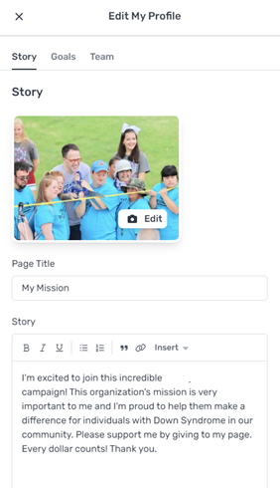

### Send donor invitations directly through your page

We know asking for donations may seem daunting, but we’ve got some tools to help you. The “Invite Donors” feature on your fundraising page is a handy tool that:

* Sends out gentle, automated reminders
* Allows you to quickly view and invite past donors
* Makes it easy to follow up and thank your donors
* Includes a pre-written message for your donors that you can personalize

**📝 HOW TO:** Start by visiting the campaign page while logged in. Head to the “Donors” tab on the Pledge It menu bar. Click the green “Invite Donors” button, then follow the prompts to send email invitations! [Watch a video of how it works.](https://pledgeit.wistia.com/medias/ng9gtmy0hr)

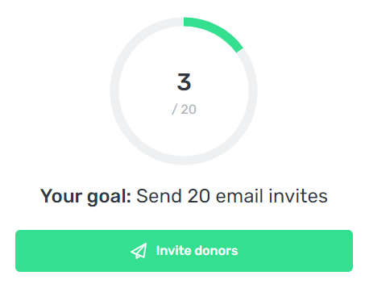

### Thank your donors!

Your donors are a key part of our campaign’s success and we hope you take the time to thank them in a timely manner. A personal thank you goes a long way to ensuring they support you next year too!

**📝 HOW TO:** You’ll receive an email every time someone donates to you with a button to thank them, or you can visit the “Donors” tab to see your donors. You’ll see a “thank you” button next to each donor’s name. Click it to load a pre-written email you can personalize before sending.

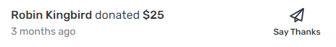

### Post an update to share with your donors and the Community

Thanking your donors is important, but you can also share updates with them before and after The Extra Mile®! We recommend sharing an update or two on your fundraising page before the event to share your excitement, then following after the big day with some photos of you and your team!

📝 **HOW TO:** Start by visiting your fundraising page while logged in. Select “Community” on the Pledge It menu bar, located at the top of the page on desktop, or the bottom of your screen on a mobile device. Add a personal message and then upload a photo, video, or social media post.

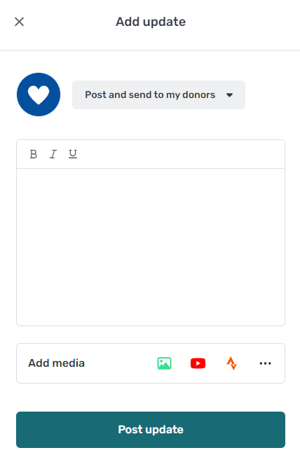 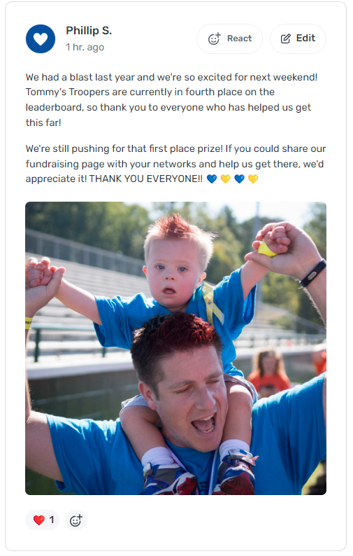

### Make the most of your Team Dashboard

If you’re on a fundraising team, you’ll have access to a team dashboard that includes a private message board just for your team members. This is a great space to share fundraising tips or challenge each other to get the most donations.

📝 **HOW TO:** Watch a [video tutorial](https://pledgeit.wistia.com/medias/uou7y6dywy) about how to use the Team Dashboard or view this [handout](https://drive.google.com/file/d/1Wt0uKONZ5FRqHjC0n16-iUrw1QOTjqaI/view?usp=share_link) for tips.

## 

## Fundraising Advice

* **Nervous to ask for donations?** You’re giving people an opportunity to support a cause (and a person, a.k.a your loved one with Down syndrome!) that matters to them, so don’t be afraid to reach out. Your supporters will feel honored that you chose to think of them and share this opportunity!
* **It’s normal to send reminders!** People are busy and your first few requests to donate may have gotten overlooked. Don’t worry if you didn’t hear back right away – follow up with a reminder and an update about how excited you are for the big day!
* **Broaden your circle!** Your family and closest friends should be the first folks you ask, but don’t stop there. Consider asking your employer, work colleagues, teachers, classmates, church members, or neighbors to contribute to your effort. You can even recruit your closest friends to help share your fundraising page on social media if you need an extra boost!
* **A little “friendly competition” can go a long way!** Do you know another family participating in the campaign? Try announcing a challenge to see who can raise the most funds between you!

## 

## Questions? Need support?

We’re so grateful that you’re joining us and helping us reach our fundraising goal. Our The Extra Mile® team is here for you if you need help. Don’t hesitate to reach out if you need help!